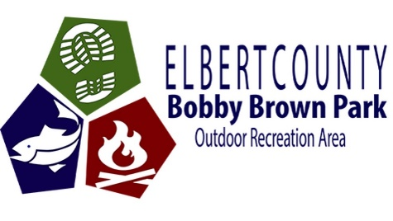

Bobby Brown Campground Regulations

1. Tent campers are restricted to the designated camping sites and may not camp in the undesignated areas.
2. Pets must be well behaved, attended to at all times, and on a six-foot leash. You are responsible for cleaning up your dog waste within **ALL PUBLIC AREAS**. Just covering the waste with leaves or pine straw is **NOT** acceptable. **If pet waste is found on site, you are subject to a $35 charge.**
3. Quiet hours are 10:00 p.m. till 7:00 a.m. Sunday – Thursday, and 11:00 p.m. till 7:00 a.m. Friday – Saturday.
4. An adult must accompany all campers under the age of 18.
5. Campfires must be in designated fire rings. **(Do not burn drift wood from the lake.)**
6. Outside firewood is strictly prohibited. Cutting or damaging trees is strictly prohibited.
7. Campers must check out no later than 11:00 a.m. on their departure date. Check in is 1:00 p.m.
8. All vehicles must display a BBP park pass.
9. All visitors must be out of the park before 10:00 p.m.
10. No weapons are allowed on the park.
11. Visitor vehicles must be parked in a designated area and not blocking roadways.
12. Take all garbage to the dumpster. (**NO FISH WASTE FROM THE FISH CLEANING STATION IS TO BE PLACED IN THE DUMPSTERS!**)
13. Speed limit in the campground and day use area in 15 MPH.
14. Speed limit in campground loop roads in 5 MPH.
15. No alcoholic beverages allowed outside your campsite area.
16. Golf carts must meet all requirements. See Golf Cart Regulations.
17. **ALL POWERED VEHICLES MUST YIELD TO PEDESTRIANS AND BIKE TRAFFIC ON THE ROAD!**